Growing
Up

(Print front and back)

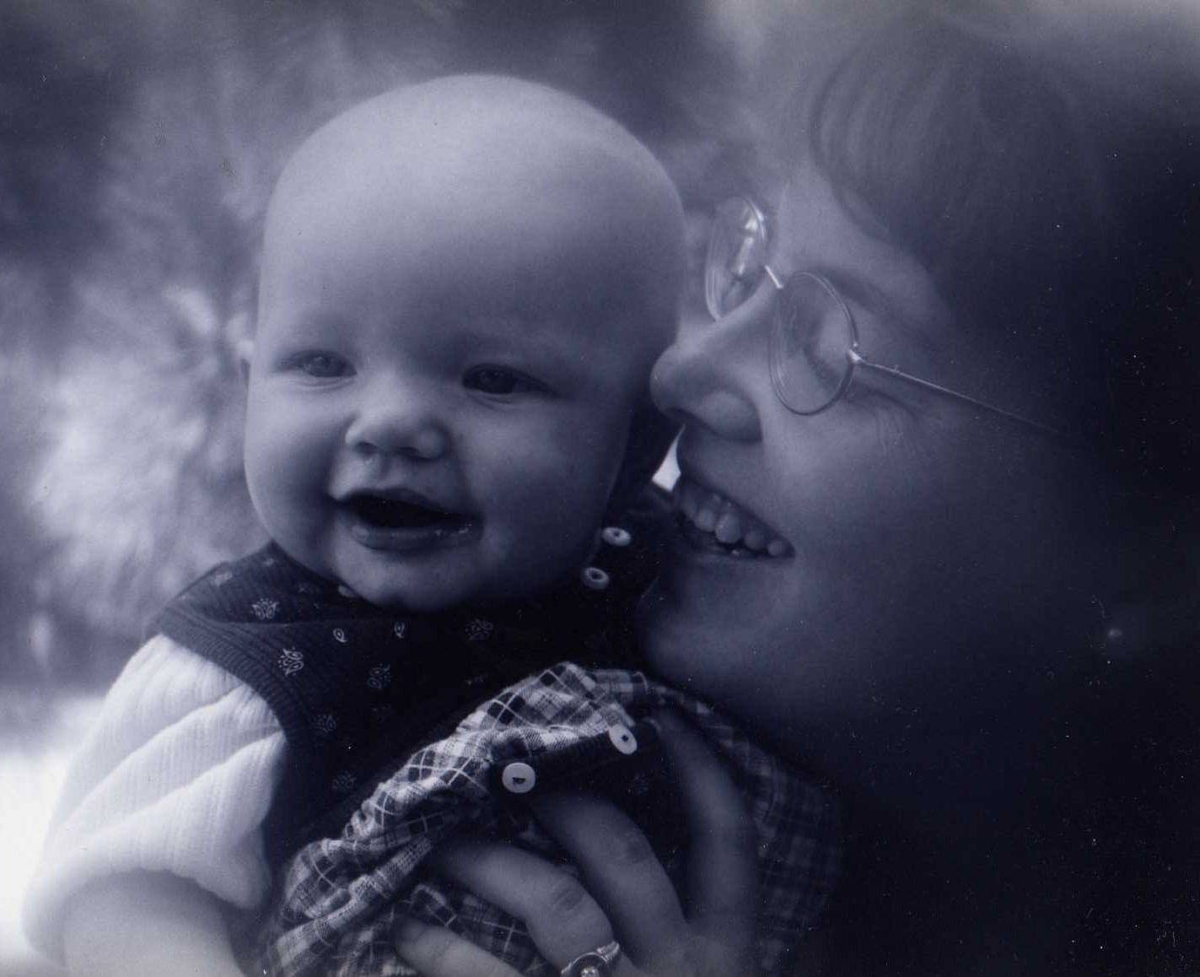
April 1, 2011

Dear _____________,

It seems like just yesterday that I held you in my arms for the first time. You were so beautiful, so pure, and so perfect! And you were ours!

What a precious treasure from our Father in Heaven. You were a part of me and a part of the person I loved most in all the world, your Daddy. Your little body had grown under my heart for nine months now, planted there by the special love between your father and me. Our Heavenly Father had sent your spirit to bring life to this body and to begin life in this eternal family which had begun in the temple when your Daddy and I were married.

I can’t believe that it has been 10 years since you came to us. You have brought such joy to our home and it has been a wonderful experience to watch you grow and learn about the world around you. I am so excited to see the young woman you are becoming.

You are entering a new time of your life, as you change from a little girl to a young lady and begin to prepare for your mission on earth of being a wife and a mother.

Your body is beginning to make some changes now, and your mind is, also. You’re beginning to think about new things and make important decisions. For this reason we feel you are ready to learn more about Heavenly Father’s plan for you on this earth as His and our daughter, and as the wife and mother in your future family. That is why we are having our date today.

I want to talk to you about some very special experiences we have in this life. I also want to answer any questions you may have about these things. This book has been prepared just for you. It will talk of many important and wonderful things. I hope you will read it often and discuss these things with me and your dad many times over the next few years. We want to help you in every way you need us during these important growing years of your life.

So, let us begin . . .

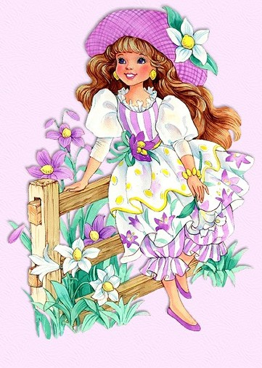
Isn’t it fun to be a girl?

Girlhood is the time for playing with legos and dolls, riding bikes, eating ice cream;

For playing dress up and giggling with sisters, cousins and friends;

For making cookies, practicing music lessons, and reading when the lights should be out!

Girlhood is the time for dreaming dreams, too . . .

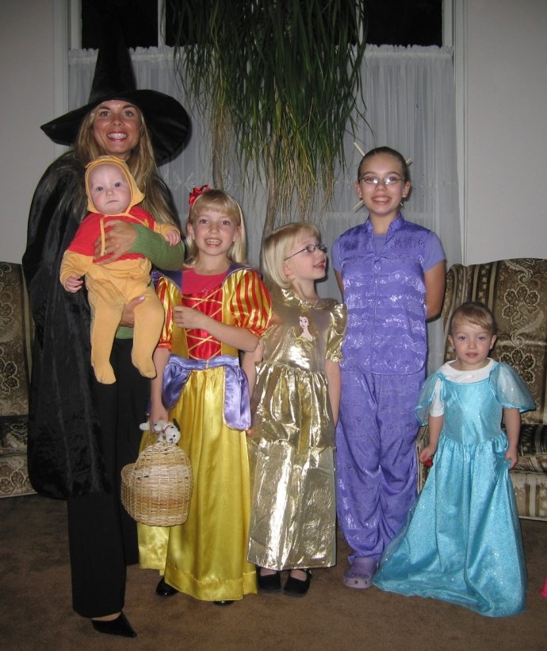
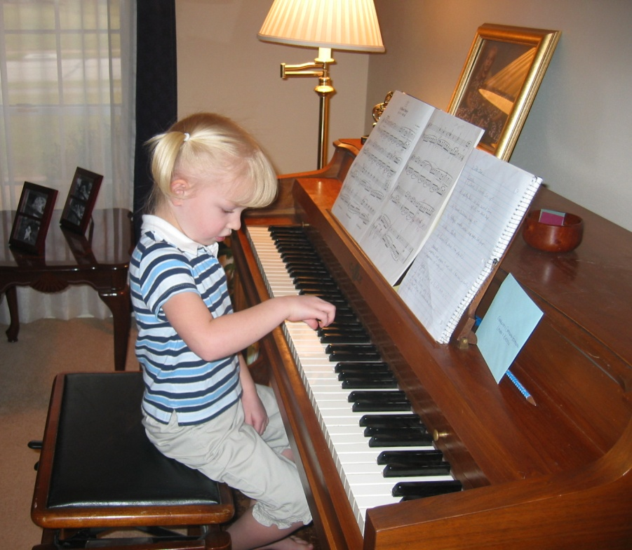

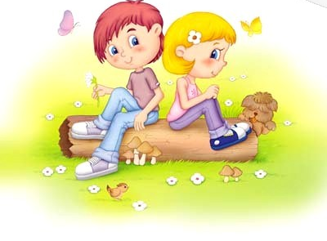
Have you ever dreamed you were a princess and your prince carried you off to a castle to live “happily ever after?”

Maybe you’ve found yourself dreaming of the boys in your classes at school or church—or about one special boy in your own imagination (the kind of boy you’d want your “prince” to be!).

Boys are many things to girls—strong fathers,
teasing cousins,
smiling grandfathers,
laughing uncles!
But boys can also be friends (and lots of fun to be around)!

Someday, one special boy, who is your best friend, will make you a bride, and later a mother.

Most girls dream of that far-away day when they will finally become a wife and mother. Have you ever dreamed such dreams? If you haven’t yet, don’t worry, that time will come.

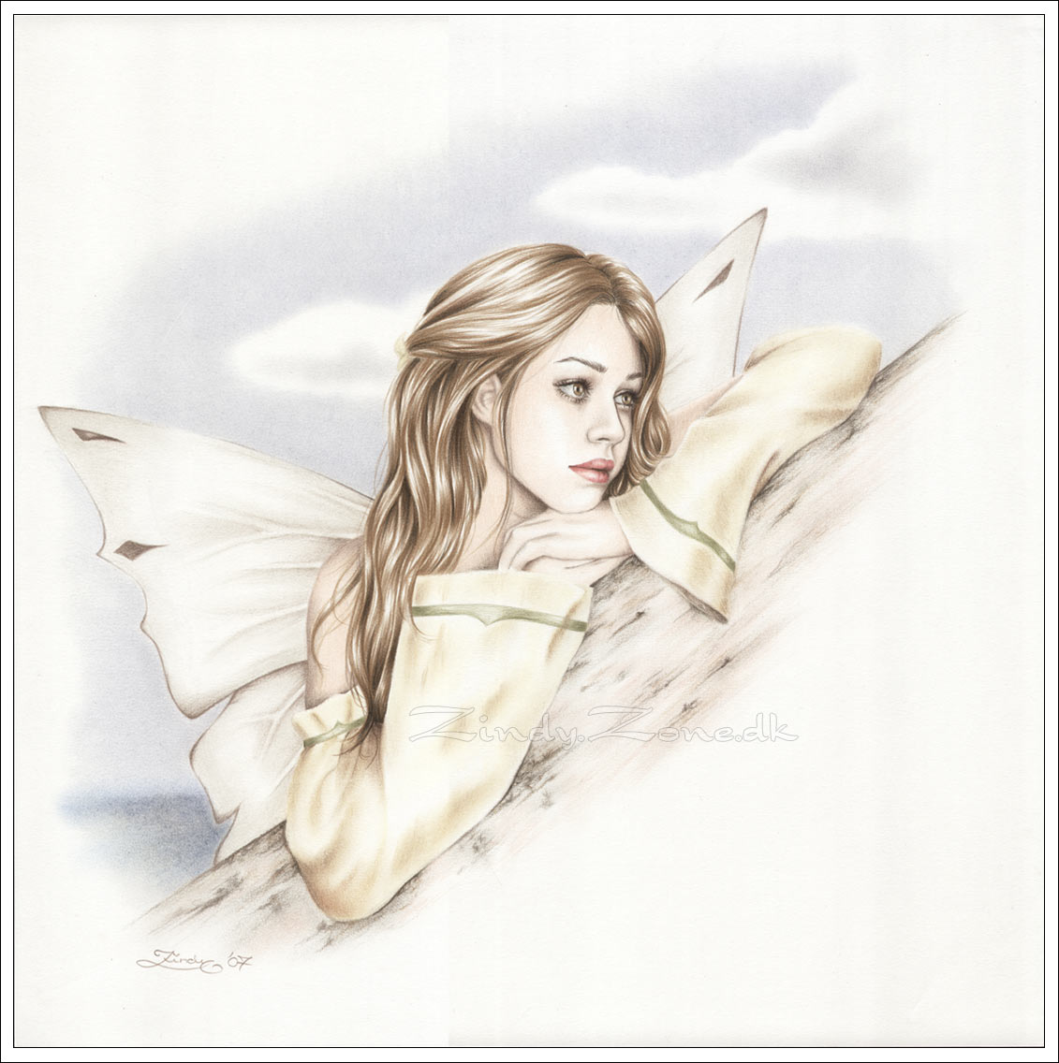
Between these dreams and the time they become real are many years. Most of these years we call teen years.

The teen years are often sweet and happy—but sometimes sad and mean years;

They may be restless, worrying, discouraging years;

Not a child—not an adult—just in-between years;

Either too tall or too small—too fat or too lean years;

The why-pick-up-clothes and keep-my-room-clean years;

Won’t-go-to-bed, can’t-wake-up-in-the-morning years;

Lazy, leave-me-alone, let-me-dream years.

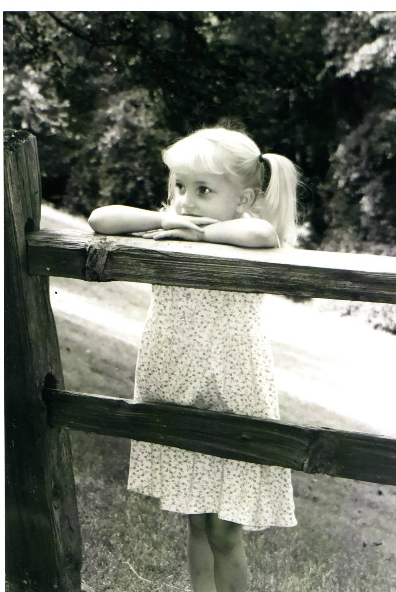

But these teen years are also joyful-light-hearted, laughing years;

Imagining, questioning, wondering years;

Studying, learning, accomplishing years;

Physically fit, sports loving years,

Three-cheers-for-our-school-team years;

The dating (after 16), dancing (at 14) years;

Romantic, star gazing, daydreaming years.

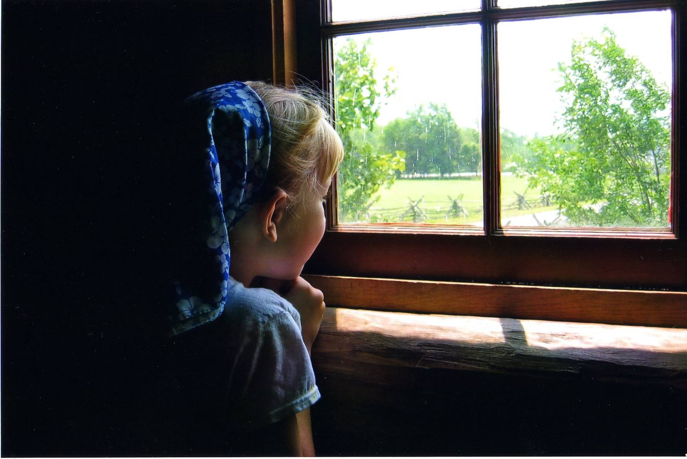
The teen years are growing years. These are the years your mind and body are preparing you to become first a bride, and then a mother!

I would like to share with you today our Heavenly Father’s wonderful plan for his sons and daughters to make them fathers and mothers. Knowing this plan will help you understand the changes your body is making, the new feelings you are experiencing, and the exciting questions coming to your mind as you grow and mature.

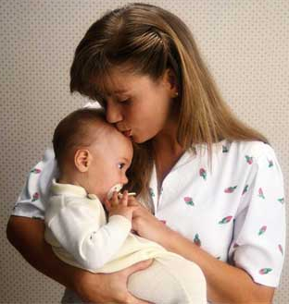
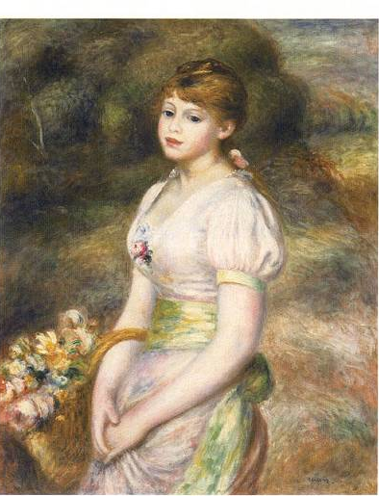
It was part of our Heavenly Father’s plan to give each of us a wonderful gift: a body that would not only clothe our eternal spirit, but which would also have within it the power of creation.

When we are born, and until we reach a stage in life called puberty, our bodies are those of little girls or little boys. These bodies do not have the ability to create babies. But when we reach the age of puberty (usually around the age of 10-14 for girls, and a little later for boys), exciting things begin to happen. Our bodies begin to make changes which turn girls into women capable of becoming mothers, and boys into men capable of becoming fathers.

Some of these changes you are already noticing in yourself. Your breasts are developing, your sebaceous glands are beginning to work harder, making your hair and face oily. Soon hair will grow on your legs and under your arms. Your arms and legs will grow longer, your hips will become broader and your waist narrower.

The funny thing about these changes is that they will not happen all at once, or even at the same time as in your friends. Your arms and legs may grow faster than the rest of you, making you sometimes feel awkward or clumsy. You may get to start wearing a bra before your friends are ready. Your clothes may begin to fit differently.

You may notice that you look and feel better if you bathe and shampoo two or three times a week. The time will come when you will want to use deodorant and shave your legs or under your arms.

Sometimes all these changes may seem embarrassing or bewildering. But it helps to remember that everyone goes through these things, and that it’s all a part of becoming someone very special and beautiful.

Boys have some changes that girls do not go through, such as growing whiskers and having their voices get deeper. But girls have one happening that boys do not share, and that is something very special. It is called menstruation.

Menstruation! What is that? Well, it’s a big word for an important part of a girl’s life. It is the change that finally makes it possible for a girl to become a mother someday.

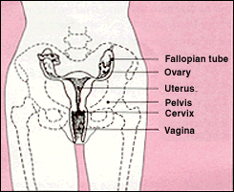
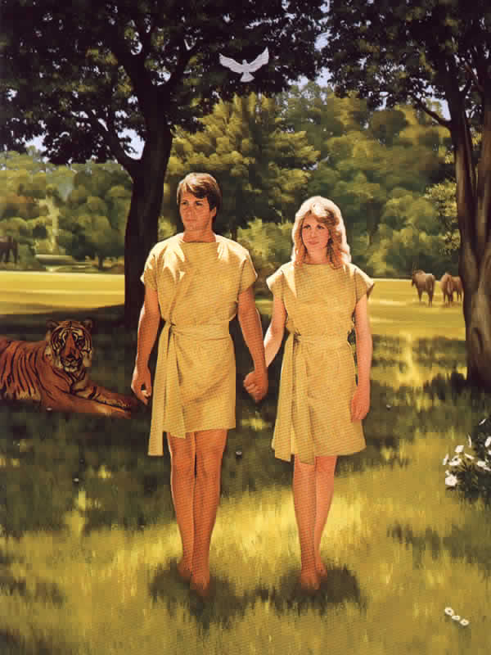
Have you every heard of older girls talking about their periods? They are talking about something that happens to them about every month. To explain, first let me show you a diagram of what is inside of you and every other girl . . . .
Every girl is born with egg cells inside her ovaries. When a girl reaches puberty, each month an egg is released from the ovary. When it travels through the Fallopian tube to the uterus, it is planted in a special lining of blood and tissue. This lining builds up in the uterus so that in case you want to have a baby, it will have a soft place to grow. But if you aren’t having one, you don’t need that lining. So it flows out through your vagina. And that’s menstruation.

What if a man and a woman, a husband and wife want the egg to become a baby? How can they make that happen?

Before the egg can grow into a baby, it must become what we call fertilized. By this we mean that a sperm cell from the father must join with the egg cell from the mother. When this happens, the two cells combine and begin to develop into a new baby.

How does the sperm cell get to the egg cell? Well, here is where you will learn the reason for the wondrous differences between a man and a woman.

We say that a woman’s sexual organ is the vagina. This is the special opening in her body through which a baby is born. But it is also the soft and warm place that receives the man’s sexual organ so that a baby may be started.

You know that boys have a penis. This is the man’s sexual organ that releases a special fluid containing sperm cells. The husband places his penis in the wife’s vagina and releases the sperm which travel to the uterus. When one of the sperm unites with the egg cell in the uterus, the egg is fertilized and begins to grow and develop into a baby.

Do you have any questions about anything I have told you?

When a man and a woman, a husband and a wife unite in this way, it is called sexual intercourse. It is a very special and wonderful experience, so special that we say it is sacred. It is the way that God ordained that a man and woman can become partners with Him to bring a child into this world. The man and woman, the husband and wife, unite together in love to “plant the seed” by which a new body may be formed. Heavenly Father then sends a spirit to that body to create a living soul, a child of loving earthly parents and the spirit child of God.

Our Heavenly Father planned for these things to be. He gave Adam and Eve to each other to be man and wife and commanded them to have children. He has blessed us with temples where we may become husband and wife and make promises to have children here and live worthily of being a family forever. Then He knows that when we unite in that special way and a baby begins to grow, the spirit He sends to that body will have righteous and loving parents who will care for His child and help him or her return with them to Him again someday.
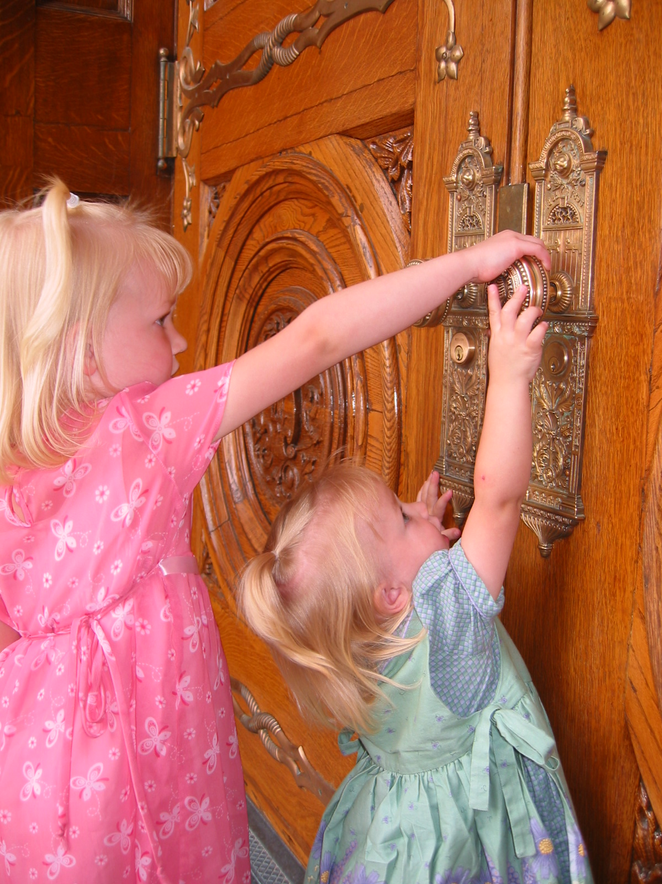
So you see, as a daughter in our Father’s kingdom, you have a very special mission to look forward to—being a wife and mother in Zion. Your mind and body are beginning to prepare for that mission.

Can you begin to understand why it would be important for you to care for your body, keeping it clean and healthy and strong?

Can you begin to realize how important it is to have good friends and cultivate the right kinds of friendships with the right kind of boys?

Can you begin to realize how important it is to set your sights on a temple marriage, where you can become a wife according to our Heavenly Father’s plan so that you and your husband might become partners with our Father in Heaven in bringing his spirit children to this earth?

Do you know who you are
Little child of mine,
So precious and dear to me?
Do you know you’re a part
Of a great design
As vast as eternity?

Can you think for a moment
How much depends
On your holding the iron rod?
Your life is forever,
Worlds without end.
Do you know you’re a child of God!

(from “To a Child,” by Ora Pate Stewart)
These things we’ve discussed today are holy, wonderful, and must be kept sacred. We shouldn’t talk about them jokingly or disrespectfully, but they should be treated with reverence. Sometimes people don’t know the whole plan and they take one part of it and speak of it in an unclean manner. But you and I know that we must be reverent about the things of God. They are not really “secret” for everyone learns about them sooner or later. But they are for mothers and daughters to talk about in their own homes.

I want you to ask me about anything which you have questions about or even about things we might not have talked about today. I hope you will always feel comfortable coming to me or your Dad with any questions as you continue to grow and learn about these things.

I love you. Daddy loves you, and we are so glad that you are a part of our eternal family. We are so proud of you and we want to share in your life as much as you will let us. Let us know when you are worried, when you are happy, and when you are sad. God has entrusted you to us until that time when you and your husband become one in His temple.

May our Father in Heaven watch over and bless you always,

Love,

